# University of Cape Town

# Department of Oceanography

# 1st Semester 2014 EXAMINATION

# SEA2004F – PRINCIPLES OF OCEANOGRAPHY

INSTRUCTIONS :

Attempt all questions.

TIME : 3 hours

(Total: 150 marks)

(The Final Exam counts 60% towards your final mark for the course).**SECTION A: (3 marks per question)**

1. 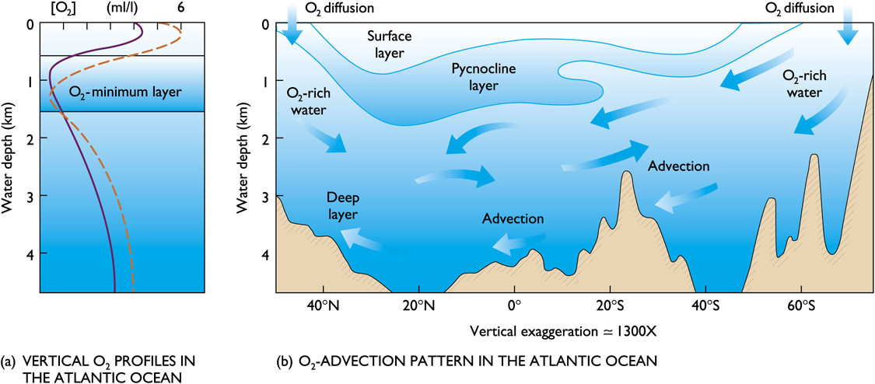With the aid of a diagram explain how the pycnocline influences dissolved oxygen concentrations?

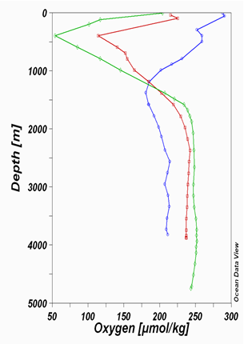

Oxygen tends to be abundant in the surface layer and deep layer bottom, but lowest in the pycnocline. Surface layer is rich in oxygen because of photosynthesis and contact with the atmosphere.

Oxygen minimum layer occurs at about 150 to 1500m below the surface and coincides with the pycnocline. Sinking food particles settle into this layer. The food draws large numbers of organisms which respire, consuming oxygen. Decay of uneaten material consumes additional oxygen.

Density difference prevents mixing downward of oxygen-rich water from the surface or upwards from the deep layer.

The deep layer is rich in oxygen because its water is cold and under pressure. Consumption is low because there are fewer organisms and less decay consuming oxygen. Anoxic waters contain no oxygen and are inhabited by anaerobic organisms (bacteria).

1. What is meant by the term Lagrangian measurement? Give two advantages and two disadvantages of this method.

Eulerian - measurements at a fixed location. Examples: single profiles, moored instruments, satellites, spatial averages of Lagrangian measurements

Lagrangian - measurements following the flow. Examples: drifters, floats

Time series - measurements over time, usually at regular intervals, long enough for spectral analysis of frequency content

Synoptic – “snapshot”

Advantages

* easier to measure transport pathways
* allows for the collection of more data spread over a larger area

Disadvantages

* less intuitive
* requires device movement
* difficult tomake for extended periods
* results one obtains greatly depends on the precise location and time a given water mass is examined with a drifter or dye

1. With the aid of a diagram explain the difference in ice formation between calm and rough seas.

As the ocean water begins to freeze, small needle-like ice crystals called frazil form. Because salt doesn't freeze, the crystals expel salt into the water, and frazil crystals consist of nearly pure fresh water. Sheets of sea ice form when frazil crystals float to the surface, accumulate and bond together. Depending upon the climatic conditions, sheets can develop from grease and congelation ice, or from pancake ice.

In calm waters, frazil crystals form a smooth, thin form of ice, called grease ice for its resemblance to an oil slick. Grease ice develops into a continuous, thin sheet of ice called nilas. Initially, the sheet is very thin and dark becoming lighter as it thickens. Currents or light winds often push the nilas around so that they slide over each other, a process known as rafting. Eventually, the ice thickens into a more stable sheet with a smooth bottom surface, called congelation ice. Frazil ice cannot form in the relatively still waters under sea ice, so only congelation ice developing under the ice sheet can contribute to the continued growth of a congelation ice sheet. Congelation ice crystals are long and vertical because they grow much slower than frazil ice.

If the ocean is rough, the frazil crystals accumulate into slushy circular disks, called pancakes or pancake ice, because of their shape. A signature feature of pancake ice is raised edges or ridges on the perimeter, caused by the pancakes bumping into each other from the ocean waves. If the motion is strong enough, rafting occurs. If the ice is thick enough, ridging occurs, where the sea ice bends or fractures and piles on top of itself, forming lines of ridges on the surface. Each ridge has a corresponding structure, called a keel, that forms on the underside of the ice. Eventually, the pancakes cement together and consolidate into a coherent ice sheet. Unlike the congelation process, sheet ice formed from consolidated pancakes has a rough bottom surface.

Once sea ice forms into sheet ice, it continues to grow through the winter. When temperatures increase in spring and summer, the first-year ice begins to melt. If the ice does not grow thick enough over the winter, it will completely melt during the summer. If the ice grows enough during the winter, it thins during the summer but does not completely melt. In this case, it remains until the following winter, when it grows and thickens and is classified as multiyear ice.

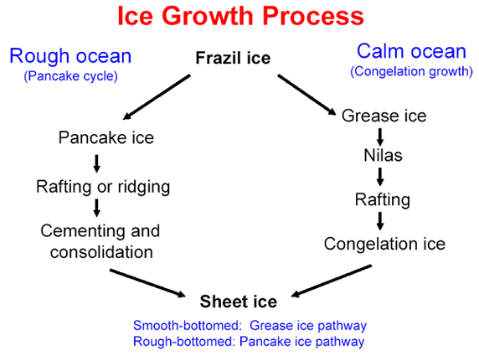

1. What is meant by the term “Western Boundary Current Intensification”? Compare the nature of Western Boundary Currents to those of Eastern Boundary Currents. Give an example of each.

Boundary currents are ocean currents with dynamics determined by the presence of a coastline, and fall into two distinct categories: western boundary currents and eastern boundary currents.

Eastern boundary currents are relatively shallow, broad and slow-flowing. They are found on the eastern side of oceanic basins (adjacent to the western coasts of continents). Subtropical eastern boundary currents flow equatorward, transporting cold water from higher latitudes to lower latitudes; examples include the Benguela Current, the Canary Current, the Humboldt Current, and the California Current. Coastal upwelling often brings nutrient-rich water into eastern boundary current regions, making them productive areas of the ocean.

Western boundary currents are warm, deep, narrow, and fast flowing currents that form on the west side of ocean basins due to western intensification. They carry warm water from the tropics poleward. Examples include the Gulf Stream, the Agulhas Current, and the Kuroshio.

Western intensification is the intensification of the western arm of an oceanic current, particularly a large gyre in an ocean basin. The trade winds blow westward in the tropics, and the westerlies blow eastward at mid-latitudes. This wind pattern applies a stress to the subtropical ocean surface with negative curl in the northern hemisphere and a positive curl in the southern hemisphere. The resulting Sverdrup transport is equatorward in both cases. It is because of western intensification that the currents on the western boundary of a basin are stronger than those on the eastern boundary.

1. Compare and contrast spring tides and neap tides. Discuss when they occur, as well as the alignment of the Earth–moon–sun system.

Spring tides occur when Earth, Moon and Sun are aligned in a straight line. Neap tides occur when the Earth, Moon and Sun are aligned forming a right angle. Neap tides are especially weak tides, while the spring tide is a rare, unusually high tide.

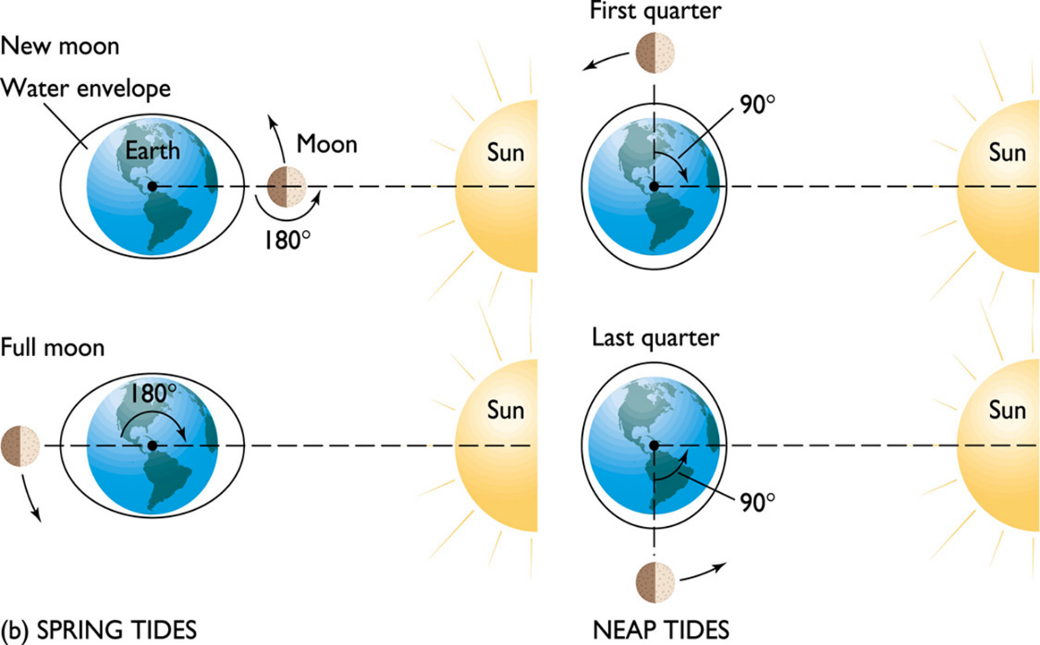

1. Provide a side-on sketch of a Cyclone and Anticyclone in the atmosphere. Include the presence of cloud, air movement and atmospheric pressure.

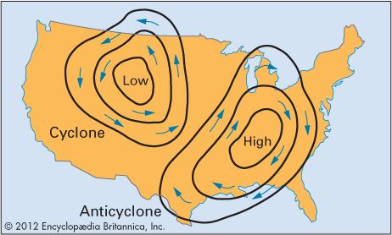

Cyclone:

A a large-scale system of air circulation in the atmosphere in the zones between the equator and either of the poles. It can be considered as either producing or resulting from differences in air pressure in those zones. In a cyclone the central air pressure is lower than that of the surrounding environment, and the flow of circulation is clockwise in the Southern Hemisphere and counterclockwise in the Northern Hemisphere. Cyclones are also characterized by low-level convergence and ascending air within the system.

Anticyclone:

Has characteristics opposite to that of a cyclone. That is, an anticyclone's central air pressure is higher than that of its surroundings, and the airflow is counterclockwise in the Southern Hemisphere and clockwise in the Northern Hemisphere. Anticyclones are usually characterized by low-level divergence and subsiding air.

1. Give the difference between an Estuarine and Anti-Estuarine circulation in terms of precipitation and evaporation. Give an example of a marine system that has an Anti-Estuarine circulation.

Estuarine water circulation is controlled by the inflow of rivers, the tides, rainfall and evaporation, the wind, and other oceanic events such as an upwelling, an eddy, and storms. Estuarine water circulation patterns are influenced by vertical mixing and stratification, and can affect residence time and exposure time. Precipitation provides fresh water to estuaries in the form of surface runoff, ground water inflows, and direct transfer of rain.

Inverse estuaries occur in dry climates where evaporation greatly exceeds the inflow of freshwater and precipitation is little. In an antiestuary, the inflow of low-salinity surface water is layered above a deeper outflowing (seaward), dense, high-salinity water layer. A salinity maximum zone is formed, and both riverine and oceanic water flow close to the surface towards this zone. This water is pushed downward and spreads along the bottom in both the seaward and landward direction. The maximum salinity can reach extremely high values and the residence time can be several months. In these systems, the salinity maximum zone acts like a plug, inhibiting the mixing of estuarine and oceanic waters so that freshwater does not reach the ocean. The high salinity water sinks seaward and exits the estuary.

Anti-Estuarine- excess evaportation

Estuarine – excess precipitation

Examples: Mediterranea- Gibraltar- Atlantic Persian Gulf- Hormuz Strait- Indian Ocean Red Sea – Bab el Mandeb- Indian Ocean

1. Sketch the approximate trajectory of a drifter off the west coast of South Africa that is subject to an Inertial Current. How long would it take for the drifter to complete one rotation at a latitude of 30 degrees South? (T = 12/sin(degrees).

period = 12 / sin(30)

1. Provide a sketch of a Generalized Marine Food Web in a typical coastal water column.

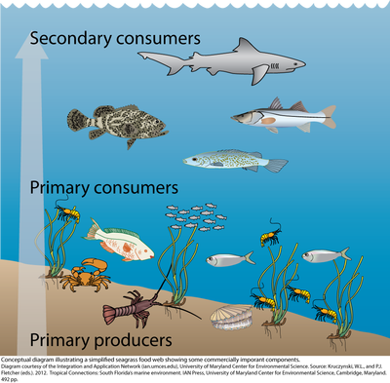

Tertiary Consumers

|

Secondary Consumers

|

Primary Consumers

|

Primary Producers

1. When considering nitrogen fixation, explain why the North Atlantic sub-tropical gyre is P limited, while the south Atlantic sub-tropical gyre is Fe limited.

Despite similar physical properties, the Northern and Southern Atlantic subtropical gyres have different biogeochemical regimes. The Northern subtropical gyre, which is subject to iron deposition from Saharan dust, is depleted in the nutrient phosphate, possibly as a result of iron-enhanced nitrogen fixation. The iron is involved in enzymes that catalyze the nitrogen fixation process.

Although phosphate depleted, rates of carbon fixation in the euphotic zone of the North Atlantic subtropical gyre are comparable to those of the South Atlantic subtropical gyre, which is not phosphate limited. The South Atlantic Ocean receives less dust, mainly originating from Patagonia and river streams.

**SECTION B: (20 marks per question)**

**1A.** Give a sketch of an ARGO profiling float and describe how it operates. [10]

Argo is a global array of more than 3,000 free-drifting profiling floats that measures the temperature and salinity of the upper 2000 m of the ocean. This allows, for the first time, continuous monitoring of the temperature, salinity, and velocity of the upper ocean, with all data being relayed and made publicly available within hours after collection.

Argo types:

* APEX – Webb: Commercially manufactured. Largest part of Argo array.
* PROVOR – Metocean: Commercially manufactured.
* 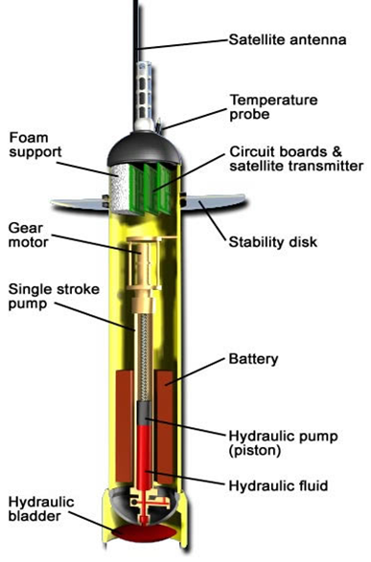SOLO – SIO and WHOI: built at institutes.

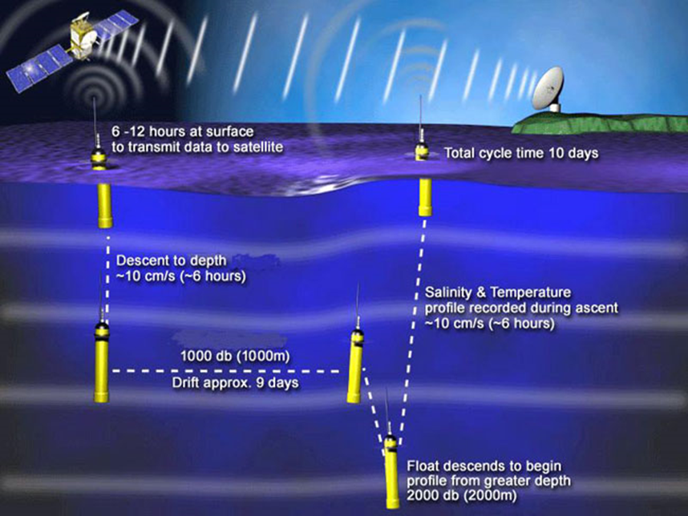

**1B.** List the advantages and limitations of this form of measurement compared to a mooring device. [10]

Adavantages:

* Float are easy to deploy, they can conduct long-lived missions and they acquire and communicate data to researchers throughout the world without the direct involvement of ships or people.
* New designs include oxygen, bio-optic sensors.
* Improve ocean models, ocean forecasting.
* Cheap compared to cruises

Disadvatnages:

* Data sets recorded by floats can contain small gaps
* No control of where they go
* Data only collected on the ascending cast
* Not always easy to get the data.

**2A.** What are the most abundant ions in sea water? [2]

* 55.0% - Chlorine
* 30.6% - Sodium
* 7.70% - Sulfate
* 3.65% - Magnesium
* 1.17% - Calcium
* 1.13% - Potassium

**2B.** Draw a speed of sound profile from the surface to 3000 m that is characteristic of any subtropical region. Label the sound speed minimum with an arrow on your diagram. Explain the increases and decreases in the sound speed profile with depth. [10]

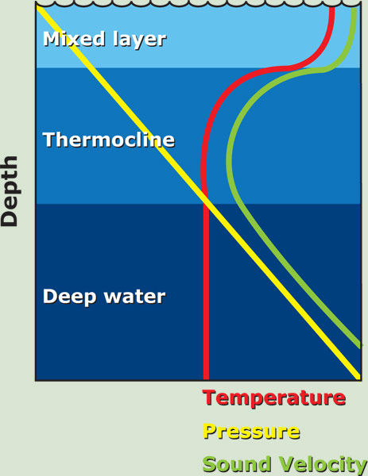

Sound is affected by water much less than light and thus has good penetration properties in water. This allows it to be used for study and communication purposes. The speed of sound is 4 times greater in water than air. The speed of sound increases with increasing temperature and pressure – due to the change in speed (Temperature) or compacting of the water molecules (Pressure).

Above the thermocline increasing pressure with depth increases the speed of sound despite the gradual decrease in temperature.

Within the pycnocline, the speed of sound decreases rapidly because of the rapid decrease in temperature and only slight increase in pressure.

Below the thermocline the speed of sound gradually increases because pressure continues to increase, but temperature only declines slightly.

**2C.** Changes in pressure with depth can be calculated using the hydrostatic equation P = ρgh where P = pressure, g = gravity = 9.8 m/sec2, h = height and ρ = density kg/m3. Using this equation show how the pressure in the water column increases at the following depths: surface (0m), 125 m, 600 m and finally at 4300 m. Assume that gravity stays the same but that density changes and is the following; 1025 kg/m3 at 0 m, 1026 kg/m3 at 125 m, 1027 kg/m3 at 600 m and 1028 kg/m3 at 4300 m. [8]

3. Describe tsunamis in detail. Discuss the characteristics of tsunamis, the difference between tsunamis and wind generated waves as well as the genesis of tsunamis. Also comment on why they are so destructive. [20]

Tsunami:

* harbor wave
* shallow water waves because their wavelengths are so long -- deep water waves are found in water deeper than 1/2 their wavelength, but if a tsunami has a wavelength of 200 km, it would need 100 km of depth and the deepest oceans rarely exceed 11 km
* created as a result of submarine activity (volcanic, subduction, slumping)
* act more like a flooding wave. A twenty foot tsunami is a twenty foot rise in sea level
* extremely long wave length and period
* extrmeely quick moving
* powerful

Wind Generated Wave:

* usually have periods (time between crests) between 5 and 20 seconds. Tsunami periods normally range from 5 to 60 minutes
* break as they shoal and lose energy offshore

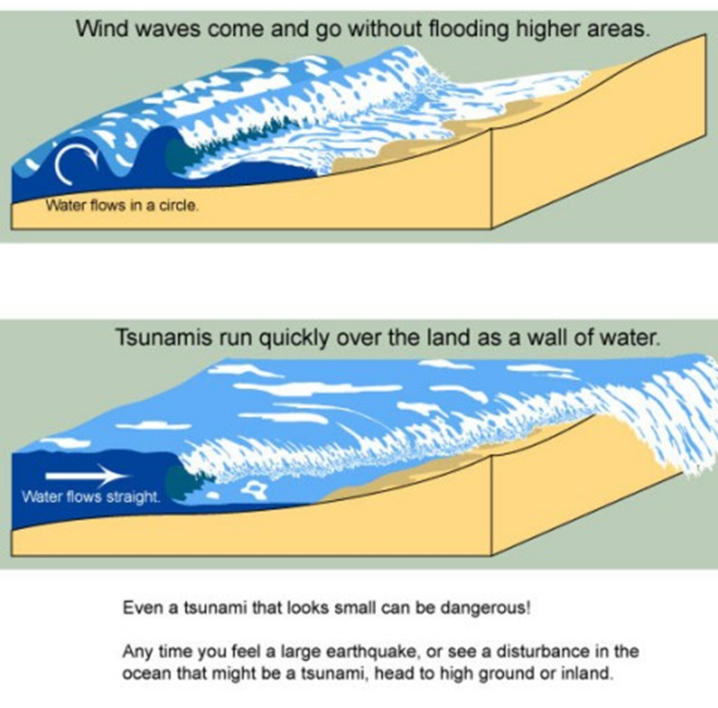

4. In the English Channel, the tidal range on the French side is greater than on the English side. With the aid of one or more diagrams explain why this is the case. [20]

The English Channel is a long and narrow basin. Currents in these basins simply reverse direction between high and low tide, flowing in with the high tide and out with the low tide. Tidal ranges increase if a bay tapers landward because water is funneled towards the basin’s narrow end. This is the case with France along the Normandy coastline. The coastline tapers inward, giving France a larger tidal range.

5(a) The volume of the world ocean is approximately 1.3 x 1018 m3. Earth’s land surface area is 15 x 1013 m2. Average salt content of ocean water is 35 x 103 g.m-3. Density of salt = 2.2 x 106 g.m-3. (n.b. density = mass / volume) If [hypothetically] the world ocean evaporated and all the solid salt in the ocean was spread over the Earth’s land surface, how deep (m) would the layer of salt be? Show your calculations. [10]

5(b) Why do Rip Currents form in the surf zone? Sketch the circulation pattern of a Rip Current in this zone. What should a person do when trapped in a Rip Current? [10]

Rip currents are formed when water pushed ashore by side currents and incoming waves, pools together and funnels back out to sea along the path of least resistance. Rips also form when outgoing rivers or streams flow into the ocean. A person should first swim parrallel to the shoreline to escape the area dominated by the current and then swim to shoreline.

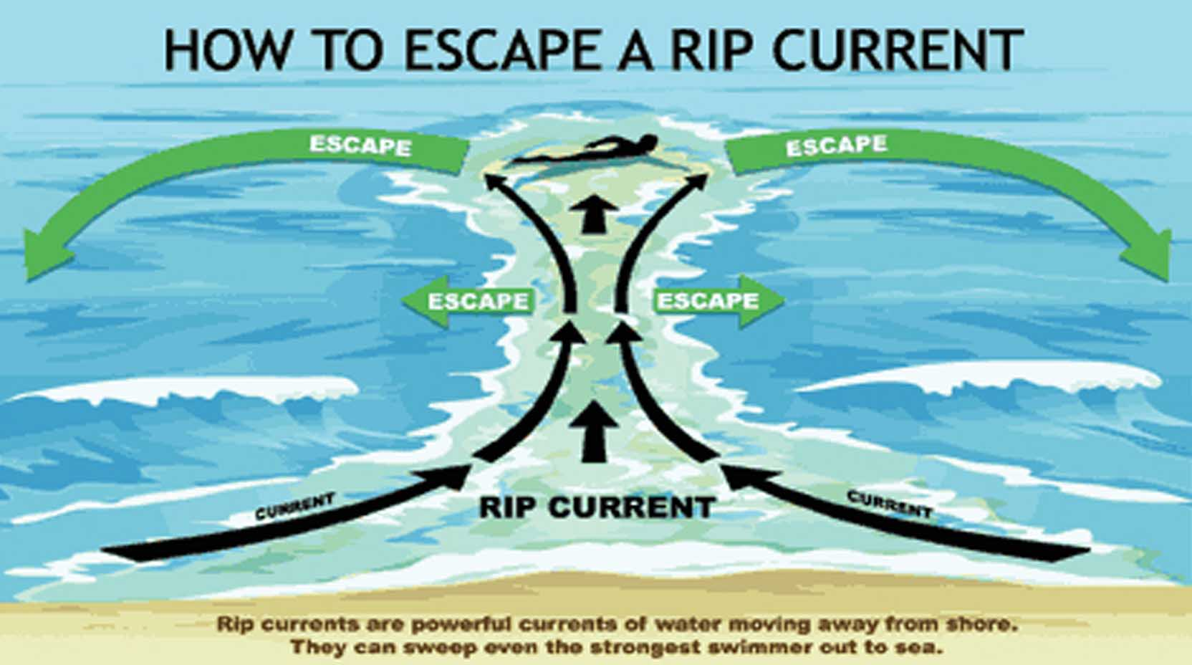

**6.** Sketch and describe the key processes of the marine nitrogen cycle and discuss what changes might occur to these cycles with climate change. [20]

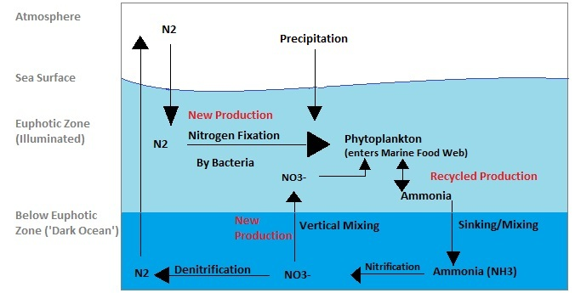

Aquatic ecosystems are critically important to N processing because of their ability to transform Nr into unreactive N2 gas during denitrification. The effect of climate change on N processing in fresh and coastal waters will be felt most strongly through precipitation changes. This will speed or slow runoff, thereby influencing the rate Nr is added to aquatic systems and groundwater, and the average time water resides in a body of water such as a reservoir, a process that aids N removal.

Other Impacts:

* More extreme precipitation events will flush fertilizer or manure into streams or groundwater. Freshwater bodies such as lakes will have less time to process and reduce excess N before it travels further downstream or is transported into the atmosphere.
* Algal blooms, which are linked to nutrient enrichment and warm waters, will occur more frequently.
* Increasing numbers of studies show correlations between N enrichment in waters and pathogen abundance and diseases of both humans and wildlife.
* American reliance on groundwater for drinking water is expected to increase under future climate change scenarios. In addition, there will likely be increases in costs for treating drinking water to avoid exposure to NO3−, which contributes to the formation of N-nitroso compounds associated with cancer, diabetes, and reproductive problems such as premature birth.